Finish Your Diploma Campaign
Local Activation Ideas

Ideas to Raise Awareness

Here are some creative and fun ways to increase the dialogue about high school completion and help more students locate programs in their community.

Online & Social Engagement:
- Do you know anyone who has a story about going back to finish their high school diploma? Encourage them to share their story on social media with the hashtag #FinishYourDiploma for a chance to be featured on our channels. You can also share by filling out our short form on our Share Your Story submission page.
- Use campaign graphics and videos to promote the topic through your social media channels. You can include messaging found on the Social Media page of the toolkit.

Join the Campaign:
- Do you want your organization listed in the campaign’s referral directory? For more information on how to become a part of the National Literacy Directory, please visit www.NationalLiteracyDirectory.org. By being a part of the campaign, potential students will be able to find your center through the campaign website, texting program, and the hotline below.
- Promote the Toll-Free hotline (1-877-389-6874). Dollar General Literacy Foundation maintains this hotline 24/7 in English and Spanish to help answer questions about the high school equivalency process and help finding centers nearby.
- Share information on your center and the campaign through newsletters and blog posts with the language found in the Spread the Word page of the toolkit.

Community Activation Ideas:
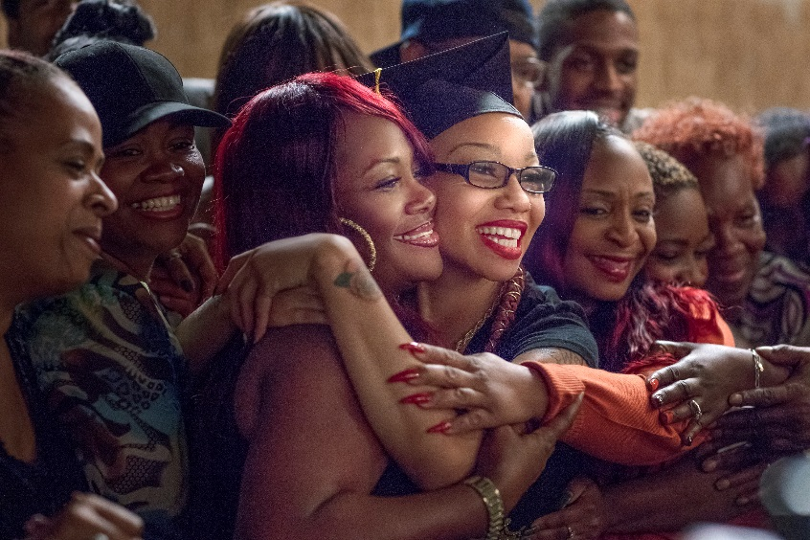
- Show the PSAs during both internal and external events, to help tell the story of High School Equivalency graduates.

